Modularized Robotic Arm

Kevin Bradshaw

Yuan Tian

Fuhua Song

Zhengshuai Zhang

**Interface Control Document**

REVISION – Draft

23 February 2016

Interface Control Document

for

Modularized Robotic Arm

Prepared by:

_____________________________

Author Date

Approved by:

_____________________________

Project Leader Date

_____________________________

Dr. Sam Villareal Date

_____________________________

T/A Date

**Change Record**

|  |  |  |  |  |
| --- | --- | --- | --- | --- |
| **Rev.** | **Date** | **Originator** | **Approvals** | **Description** |
| **-** | 2/23/16 | Kevin Bradshaw |  | Draft Release |

Table of Contents

Table of Contents III

List of Tables IV

List of Figures V

1. Overview 1

2. References and Definitions 2

2.1. References 2

2.2. Definitions 2

3. Physical Interface 3

3.1. Weight 3

3.2. Dimensions 3

3.2.1 Dimension of the Robotic arm 3

3.2.2 Dimension of the User Interface 4

3.3. Mounting Locations 5

4. Thermal Interface 5

5. Electrical Interface 6

5.1. Primary Input Power 8

5.2. Polarity Reversal 8

5.3. Signal Interfaces 8

5.4. Video Interfaces 8

5.5. User Control Interface 8

6. Communications / Device Interface Protocols 9

6.1. Wireless Communications (Wi-Fi) 9

List of Tables

Table 1: PWM Driver Characteristics 6

Table 2: PWM Driver Pin Descriptions 6

Table 3: Raspberry Pi 2 Model B Pin Layout 7

Table 4: Panda Wireless Module Characteristics 9

Table 5: Microsoft Kinect Characteristics 10

List of Figures

Figure 1: Robotic Arm Physical System 3

Figure 2: Kinect System 4

Figure 3: Envisioned Glove Controller System 5

Figure 4: Raspberry Pi 2 Model-B Pin Layout 7

# Overview

The objective of this project is to design and construct a mechanical appendage that is controlled and operated wirelessly using a custom-designed tracking system. The purpose of this versatile robotic arm is to aid in emergency situations in which human senses and control are critical without having a physical person present. This robot would have six different tool attachments in order to interact with the surrounding environment while keeping the user at a safe distance. The difference between this robot and conventional robots with extensions is that this can be controlled wirelessly through simulation solely based on the user’s movements while still having the ability to use numerous types of tools. This brings the user’s natural movements to the situation combined with machine capabilities so that the problem can be resolved with a human’s direct perspective. Lastly, there would be a mounted utility belt in front of the arm that would be used to change the application of the hand to different kinds of projects. Depending on the situation, the utility belt would be able to revolve around the arm and attach itself to the clamp. This concept combines the mobility of the human arm and the usability of machines.

# References and Definitions

## References

**AL5D Assembly Guide (Lynxmotion.com)**

7 Oct 2009

**How does the Kinect 2 Compare To The Kinect 1 (Zugara.com)**

9 Dec 2014

**Kinect for Windows Sensor Components and Specifications (Microsoft.com)**

Mar 2016

**Panda Wireless 802.11n Wireless USB Adapter (PandaWireless.com)**

Feb 2014

**PCA9685 Datasheet (Adafruit.com)**

16 Apr 2015

**Raspberry Pi 2 GPIO Electrical Specifications (Mosaic Documentation Web)**

Mar 2016

**Raspberry Pi 2 FAQ (RaspberryPi.org)**

Mar 2016

**Single Chip 2.4 GHz Transceiver - Nordic Semiconductor (Sparkfun.com)**

Mar 2008

## Definitions

mA Milliamp

mV Millivolt

mW Milliwatt

FPS Frames Per Second

GPIO General Purpose Input and Output

Mbps Megabytes per second

PWM Pulse Width Modulation

SDK Software Development Kit

IEEE The Institute of Electrical and Electronics Engineers

# Physical Interface

## Weight

Robotic Arm: 1.5 lbs.

Kinect: 1.8 lbs.

Raspberry Pi 2 (Including Power Supply): 7.2 Oz.

Raspberry Pi 2 Expansion Board: 4 Oz.

Camera: 14.4 Oz.

Extra hardware components will add approximately 1 to 1.5 pounds of weight.

Total estimated weight: 83.97 to 91.97 Oz. or 5.25 lbs. to 5.75 lbs.

## Dimensions

### Dimension of the Robotic arm

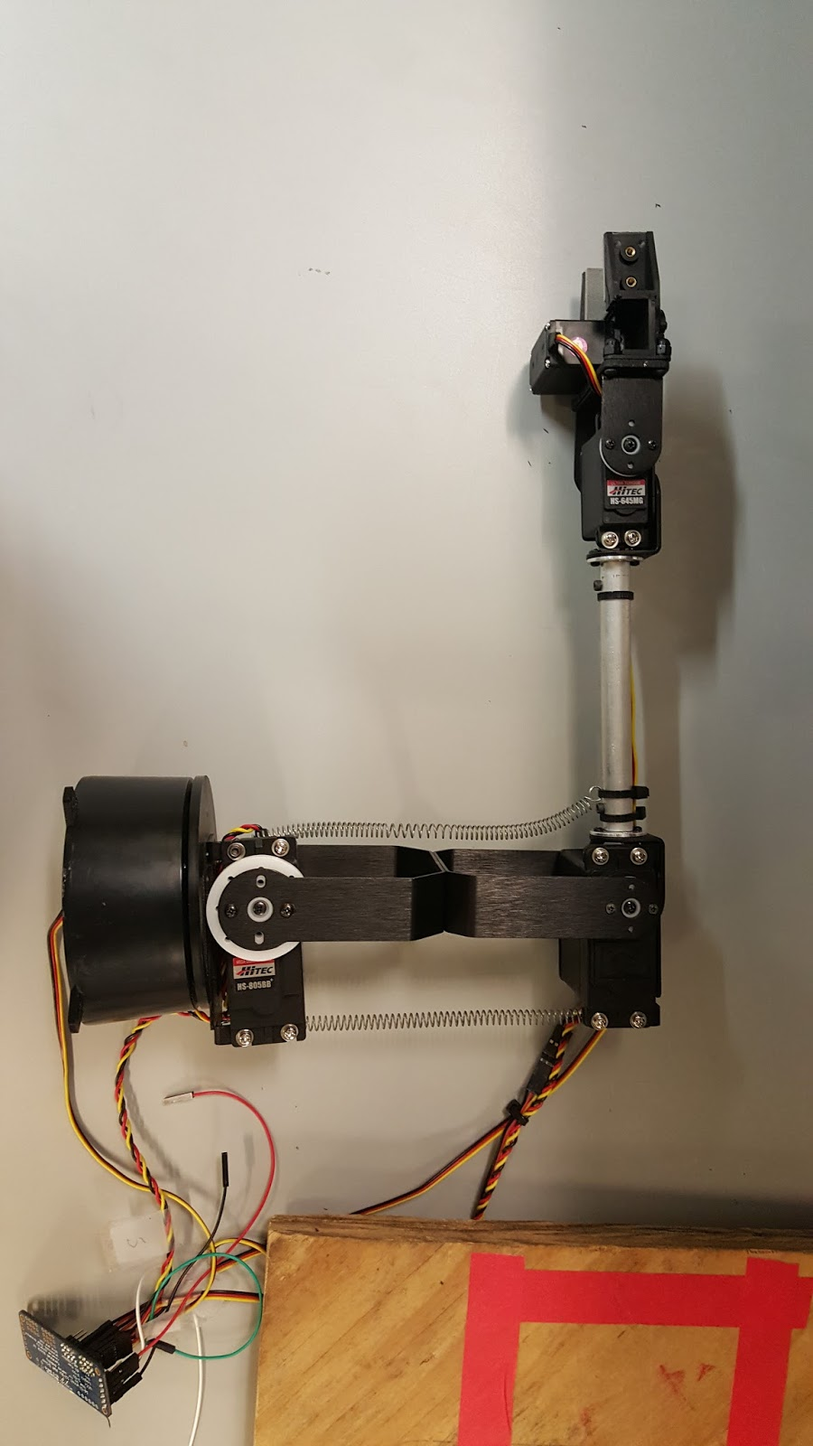When fully extended, the arm can fit in a 19” x 2” x 4” three-dimensional box. As for the total system overview, every component should fit in a 2.5’ cube. The PC and Kinect will not be mounted on the project but will be placed in a space large enough so that it can read the proper input from the user.

Figure : Robotic Arm Physical System

### Dimension of the User Interface

*1. Kinect*

Kinect dimensions:

W x D x H:  11’’ x 2.5’’ x 1.5’’

Kinect Range:

The Kinect has an effective operational range that is between 2.5ft to 13ft, within which it can identify and track human joints. The Kinect will keep searching for human-like objects if the objects are out of this range. It’s very crucial to set up a constant distance within its operational range when doing the tests and data collecting so that the data collected is accurate and reliable.

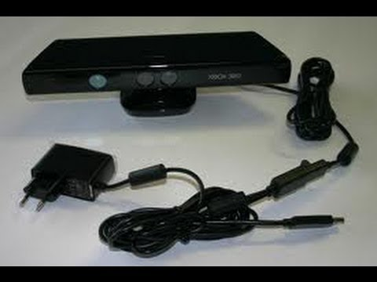

Figure : Kinect System

*2. Glove*

Glove dimensions:

Size: 9 (Large)

Gross Weight: < 8 Oz.

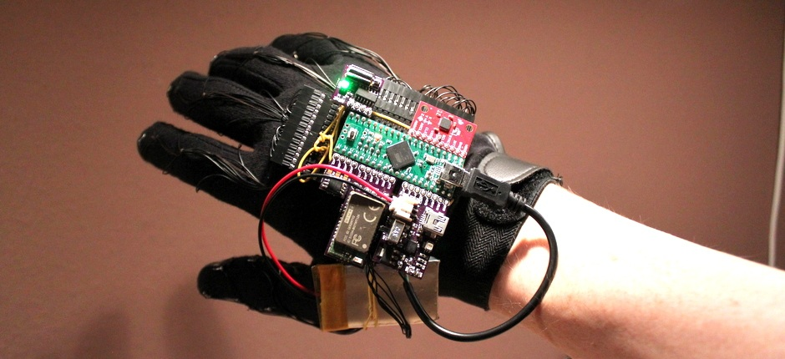

Figure : Envisioned Glove Controller System

## Mounting Locations

The robotic arm will be mounted in such a way that the shoulder (largest servo motor) will be oriented like that of a human arm with axis movement having limits on rotation. This would be so that the user has complete control over the arm as if it was their own. To do this, a simple mount may have to be constructed out of wood not exceeding over 40 lbs.

# Thermal Interface

The sensors and the components of this project will be quite heat resistant to moderate circumstances. No additional cooling module is necessary nor are heatsinks. However, air ventilation will still be taken into high priority for some specific components. For the servo motors, these are all exposed and won’t be fitted with any coverings. This allows for more than sufficient airflow to cool the motors. The raspberry pi microprocessor will also be exposed and not fitted with any covering which allows for the arm to receive more than adequate cooling.

# Electrical Interface

*PCA9685 16-Channel, 12-Bit PWM Driver*

The PCA9685 is a 16-channel LED controller that can be used for PWM outputs at a 12-bit resolution. It has a typical programmable frequency of 24 Hz to 1526 Hz with a fully adjustable duty cycle. It operates at a range of 2.3 V to 5.5 V. Using five of these channels, the servo motors of the robotic arm can be sufficiently controlled by the PWM outputs.

Table : PWM Driver Characteristics

|  |  |  |  |
| --- | --- | --- | --- |
| Parameter | Min. | Max. | Unit |
| Supply Voltage | -0.5 | 6.0 | V |
| Voltage on I/O Pins | Vss-0.5 | 5.5 | V |
| Output Current | - | 25 | mA |
| Ground Supply Current | - | 400 | mA |
| Total Power Dissipation | - | 400 | mW |

Table : PWM Driver Pin Descriptions

|  |  |  |
| --- | --- | --- |
| Symbol | Type | Description |
| GND | Supply Ground | Ground |
| OE | Active Low Output Enable | Input |
| SCL | Serial Clock Line | Input |
| SDA | Serial Data Line | Input/Output |
| VCC | Power Supply Output | Output |
| V+ | Power Supply Input | Input |

*Raspberry Pi 2 Model B:*

* Power supply:  Raspberry Pi 2 model B is powered by a 5V micro USB. It can supply 600mA/1.2A to downstream USB peripherals, switchable by a firmware setting.
* Camera board: requires 250 mA to operate
* Input voltage: 3V3 & 5 V
* Input current: 750 mA maximum
  + 250mA minimum (to supply the camera)
  + 3 mA per pin (the Raspberry-Pi 3V3 supply was designed with a maximum current of 3mA per GPIO pin.
* Output current:
  + From 3V3 rail: 50 mA
  + From 5V rail: depending on design
* GPIO pins: Used as output pins, when the pin is HIGH (on) it outputs 3.3 V (3V3); when the pin is LOW (off), and it outputs 0V.
* Input voltage and output current limitations:

1. A GPIO pin should never be connected to a voltage source greater than 3.3V and less than 0V. Never source or sink more than 0.5mA into an input pin.
2. Should not source/sink more current from the pin than its programmed limit.
3. Never demand that any output pin source or sink more than 16 mA.
4. Current source (configurable from 2mA to 16mA) by the outputs is drawn from the 3.3V supply, which can supply only 50 mA maximum.
5. Limit current into any capacitive load to a maximum transient current of 16mA.

* Video output: HDMI
* USB: 4 USB 2.0 connector

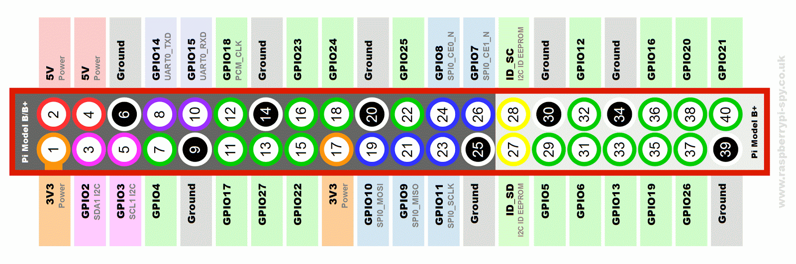

Figure : Raspberry Pi 2 Model-B Pin Layout

Table : Raspberry Pi 2 Model B Pin Layout

|  |  |  |
| --- | --- | --- |
| **Pin name** | **Pin number** | **Hardware Notes** |
| **GND (Ground)** | 6,9,14,20,25,30,34,39 | - |
| **5V** | 2,4 | supply through input polyfuse |
| **3V3** | 1,17 | draw 50mA max |
| **GPIO** | 3,5,7,8,10,11,12,13,15,16,18,19,21,22  23,24,26,29,31,32,33,35,36,37,38,40 | 3.3V(Max) |
| **ID_SD** | 27,28 | - |

## Primary Input Power

The primary power source is a 5v external power pack UPG UB1250 Sealed Lead Acid Batteries that will power the raspberry pi and the servo motors as well as the camera module. The kinect will plugged into the wall directly and will be taking in 12vs of external power.

## Polarity Reversal

A typical 5 V voltage regulator combined with a diode will be used for battery spikes and reversal from the power supply.

## Signal Interfaces

The signal used will be Wi-Fi to control the arm and the camera, the button will be controlled by the radio frequency signal.

## Video Interfaces

The video interface will be an attachable camera directly linked to the raspberry pi through the camera serial interface. The information processed will be transmitted through the Wi-Fi wireless transmitter and receiver from the raspberry pi to the computer for the user to visualize.

## User Control Interface

The Raspbian operating system for the Raspberry Pi 2 will be the primary interface that will be utilized to control the sensors, sending back visual feedback, etc. The Raspbian operating system will be downloaded from the raspberry pi website and uploaded onto a 32 bit micro SD card that will be inserted into the Raspberry Pi 2 port.

# Communications / Device Interface Protocols

Wireless communication will be a key component of this project. Since many of the interfaces such as the control of the mechanical hand will require as little latency as possible, fast yet reliable wireless transmission is critical. In order to achieve this goal, we will be utilizing Wi-Fi as the primary communication for intensive processes that require minimum latency. This includes visual feedback of the camera system and the control of the mechanical hand. Radio frequency control will also be utilized for the less intensive, digital control. The buttons on the glove will send a digital signal when pressed by the user which will determine the tool to be used which would be controlled by the RF module.

## Wireless Communications (Wi-Fi)

Wi-Fi Connection:

The Wi-Fi module used for the visual feedback and control of the mechanical hand will be the Panda Wireless PAU06 300Mbps N USB Adapter module. With 300Mbps, it should suffice to take in the data collected by and transmit this information to the PC. It would also be capable of handling the instructions transmitted from the PC. One module will be connected to the Raspberry Pi and another module would be connected to the PC. The module on the PC will be used to turn it into an access point. This would make the PC essentially into a router of which the module on the Pi would be able to connect to.

Table : Panda Wireless Module Characteristics

|  |  |
| --- | --- |
| **Panda Wireless 802.11n Adapter** | **Specifications:** |
| Protocol and Standards | IEEE 802.11 b/g or 802.11n |
| Interface | USB 1.01,  USB 2.0 |
| Frequency Band | 2.412 ~ 2.4835 GHz |
| Data Rate | For 802,11n - 150Mbps:  Peak rate: 150Mbps  For 802.11n - 300Mbps:  Peak rate: 300Mbps |
| Transmit Power | 802.11n:  14dBm |
| Data Security | WEP 64/128, WPA, WPA2, 802.1X |
| Power Consumption | 330mA and 110mA in full Transmit, 290mA and 95mA in full Receive |
| Transmission Distance | Indoor: up to 100m  outdoor: up to 300m |

Kinect Connection and Data Transmission Method:

The Kinect is connected to a PC with a USB connector, but will also have a typical AC wall adapter for its supply power. The digital data pre-processed by the Kinect is transmitted through the USB to the PC. Microsoft Visual Studio integrated with SDK libraries is used to access the data, from where a designed section of code can process the data again and feed post-processed digital information to the wireless module, which will eventually send the data to the robotic arm to drive each respective servo motors.

Table : Microsoft Kinect Characteristics

|  |  |
| --- | --- |
| **Kinect** | **Array Specifications** |
| Viewing Angle | 43° vertical by 57° horizontal field of view |
| Vertical tilt range | ±27° |
| Frame rate (depth and color stream) | 30 frames per second (FPS) |
| Accelerometer characteristics | A 2G accelerometer, with a 1° accuracy upper limit |
| Sampling Speed | 30/sec at maximum |
| Data Size | Depth Mode: 12Mb/sec  Color Mode: 9Mb/sec |

Glove Connection and Data Transmission Method:

The RF module to be used is the nRF24L01. The instructions transmitted by the raspberry pi 2 taken from buttons are simple digital signals thus this basic module would be sending information directly to the tools for movement. The glove with integrated buttons is powered by a 9V battery. Buttons when pushed will generate a digital signal that is sent to an encoder. The encoded signal is then sent to the RF transmitter, which will process and send to the receiver on the RF module. This received signal will be decoded and sent to the motor to perform specified tasks.